Data Quality
Introduction to Quality Assurance
Object name | Vending Machine — Necta Orchestra
Object description | The Necta Orchestra is a premium, high-performance vending machine designed for selling snacks, fresh food, cans, and bottles. It represents the next generation of automated retail with a focus on energy efficiency and advanced user experience.  • Dimensions & Weight: The machine has a height of 1830 mm, a width of 900 mm, and a depth of 830 mm, with a total weight of 300 kg.  • Capacity & Layout: It is equipped with 6 product trays by default (expandable up to a maximum of 8 trays) and offers a total product capacity of 438 items.  • Configurations: Supports multiple flexible layouts depending on the location needs: Snacks + Food + Cans & Bottles, Snacks + Food, pure Food, or purely Cans & Bottles.  • User Interface: Features a classic numeric selection keypad allowing for up to 46 unique product selections.  • Dispensing System: Equipped with the advanced Softvend elevator system, ensuring that delicate items (like fresh food or sandwiches) are safely and gently transported to the delivery bin without dropping or shaking.  • Temperature Control: Uses a stratified temperature layout, which creates distinct cooling zones within the cell to keep different product types (snacks, drinks, or fresh food) at their ideal preservation temperatures.  • Technical Specs & Protocols: Operates on a standard voltage of 230 Volt and a frequency of 50 Hz. It supports all standard industry communication protocols, including Executive, MDB, and BDV, for seamless integration with payment systems.
Object picture | Link: Necta Orchestra | Vendmarque  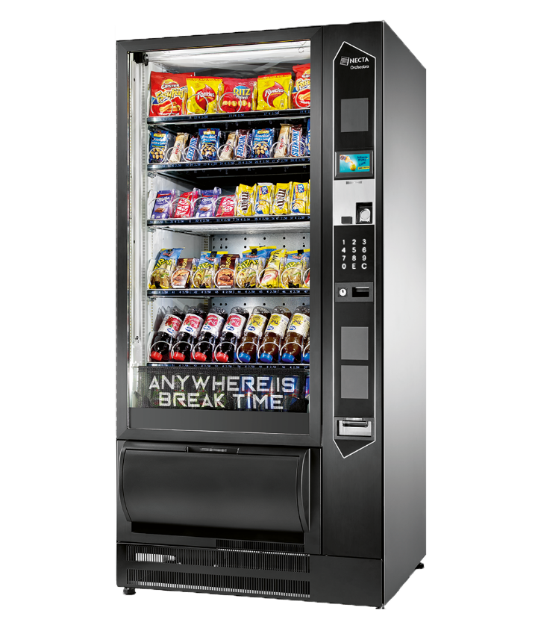
Smoke tests | Power & Startup  - The machine powers on and displays the welcome screen without errors.  - The electronic display is visible and clearly shows characters, prices, and error codes.  - The numeric keypad backlight activates upon power-up.  Basic Purchase Flow  - User inserts a coin — the machine recognises and accepts it, and the balance is updated on screen.  - User selects a product slot number — the machine highlights the selection and shows the product name and price.  - After sufficient payment, the dispensing mechanism activates and delivers the selected product to the collection tray.  - If the inserted amount exceeds the product price, correct change is dispensed back to the user.  Zero Balance Control:  - Verify that the machine does not dispense any product if no money is inserted or if the user chooses an empty slot.
Critical path tests | Payment Methods  - Purchase with banknotes: insert a 5 EUR note, select a 1.50 EUR product, verify correct change of 3.50 EUR is returned.  - Purchase via contactless bank card: tap card, confirm payment approval on screen, verify product is dispensed.  - Purchase via mobile payment (Google Pay / Apple Pay): confirm NFC transaction, verify item delivery.  - Exact change payment: insert coins equalling exactly the product price, verify no change is dispensed and product is delivered.  Product Selection & Dispensing  - Select a snack item from the upper trays: verify the Softvend elevator platform smoothly rises to the exact tray level.  - Select a delicate beverage or fresh food item: verify the Softvend elevator platform smoothly rises to the exact tray level, picks up the product safely without it falling, and gently lowers it to the delivery bin.  Display & Navigation  - Input different available product codes (up to 46 selections) using the numeric keypad; verify the screen displays correct prices and product availability status.  - Verify the current inserted balance is always visible and updates in real time as coins or notes are added.  Refund & Error Handling  - If a card payment is declined, verify the machine shows a clear error message and returns to the payment selection screen.  - If a product gets stuck mid-dispense, verify the machine detects the jam, cancels the transaction, and refunds the payment.  - If the coin dispenser runs out of change, verify the machine disables cash payment and shows an appropriate message.
Extended tests | Payment Edge Cases  - Insert a foreign coin (e.g. US quarter): verify it is rejected and returned without crediting the balance.  - Insert a bent coin: verify the machine rejects it without jamming.  - Insert coins slowly one at a time over 3 minutes without confirming a selection: verify the machine times out and returns all coins.  Keypad & UI Edge Cases  - Test physical buttons: verify that pressing keys with gloves on registers correctly.  - Test screen visibility in bright sunlight through a glass wall: verify content is legible.  Refrigeration & Environmental  - Verify the beverage zone maintains 4–8°C after 2 hours of operation in an ambient temperature of 30°C.  Security & Anti-Theft  - Attempt to open the service door without a key/code: verify the anti-theft alarm activates and an alert is sent to the operator.  - Shake the machine forcefully: verify the tilt/anti-theft sensor triggers and locks the machine.  Accessibility & Localisation  - Switch the machine language from English to a second configured language: verify all on-screen text updates correctly without missing translations.  - Test energy-saving mode: verify the screen dims after 60 seconds of inactivity and all functions resume instantly when touched.

